SBE 201: Sustainable Design Portfolio

Building a Sustainable Philadelphia: Advancing Urban Development

Brett Righter

Table of Contents

Introduction 3

Green City, Clean Waters Program 4

Philadelphia Energy Campaign 6

SEPTA’s Sustainability Program 8

Philadelphia Urban Agriculture Initiative 10

Conclusion: 12

# 

# Introduction

Philadelphia is fully dedicated to design a city where all its residents can thrive and succeed, with sustainability at the core of that vision. Building on the achievements of the Greenworks initiative over the last eight years, this portfolio will outline a long-term plan for sustainable design and planning across the city in alignment with the United Nations Sustainable Development Goals. By focusing on equitable access to healthy neighborhoods, reducing carbon emissions, and investing in renewable energy, Philadelphia aims to address the pressing challenges of climate change and environmental justice. This portfolio showcases just four key projects that illustrate Philadelphia’s commitment to sustainability and highlights the city’s ongoing efforts to ensure that all neighborhoods benefit from these initiatives.

The United Nations Sustainable Development Goals (SDGs) are a universal call to action to end poverty, protect the planet, and ensure benefit for all. Specific goals that align closely with the projects in this portfolio include:

# Green City, Clean Waters Program

*Philadelphia Water Department Commissioner Randy E. Hayman Esq., center, led a 2019 ribbon-cutting celebration for a new rain garden that also makes walking safer in Strawberry Mansion.*

The Green City, Clean Waters Program was launched in 2011 by the Philadelphia Water Department to address the significant issue of stormwater management in the city. Philadelphia’s combined sewer system, which serves about 60% of the city, often overflows during wet weather, resulting in billions of gallons of stormwater and diluted sewage flowing into local waterways each year. To meet state and federal regulations, particularity sections of the Clean Water Act, the city needed to reduce at least 85% of this pollution to avoid steep fines.

The program is a 25-year plan designed to reduce the volume of stormwater entering the combined sewers using green infrastructure (GSI) and to expand stormwater treatment capacity through traditional infrastructure improvements. Green infrastructure, also known as green tools, includes elements like rain gardens, tree trenches, and green roofs, which help manage stormwater by soaking it up and allowing it to evaporate or slowly release into the sewers. This not only manages stormwater but also provides environmental benefits such as reducing carbon dioxide, filtering pollutants, and reducing the heat island effect.

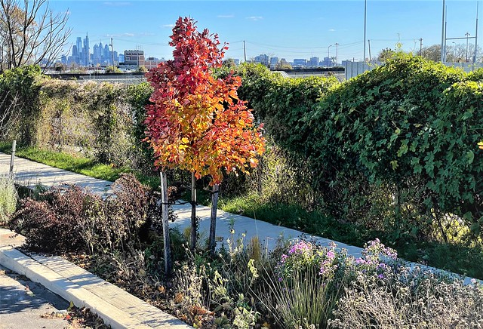

**Success Measurement:**

The success of Green City, Clean Waters is measured through various metrics including the volume of stormwater managed, the number of greened acres, and the reduction in combined sewer overflows. Specific achievements include the installation of more than 2,800 green tools at nearly 800 sites throughout the city, which have kept more than 2.7 billion gallons of polluted water out of local rivers. Additionally, community feedback and support are gauged through annual surveys, with many residents expressing willingness to pay more on their water bills to support clean water and climate change initiatives.

***Spaces to Hike, Bike, Boat, Fish, and Enjoy Nature***

***Spending Time Outside***

***Collaborating with Local Residents***

***Creates Local Jobs***

***Increase Property Values***

***Attracts and Promotes Recreation***

***Promotes Investments***

***Improved Air Quality***

***Saving Energy***

***Reducing Heat Island Impact***

***Support Important Wildlife***

To further enhance the programs impact, potential improvements could focus on expanding community education and engagement efforts to increase public awareness and participation. Additional funding and resources could be directed towards maintaining and expanding green infrastructure projects, particularly in the most heat-stressed regions of the city. Further integration of green tools into other city projects, such as athletic field renovations and public space improvements, could also provide more opportunities to manage stormwater and enhance urban environments.

# Philadelphia Energy Campaign

The Philadelphia Energy Campaign was launched by the Philadelphia Energy Authority (PEA) in 2016 with the aim of addressing energy inefficiency and promoting renewable energy across the city. The campaign was designed to combat high energy cost, reduce carbon emissions, and create job opportunities in the energy sector. This initiative was part of a broader effort to position Philadelphia as a leader in sustainability and to meet the city’s ambitious climate action goals.

The campaign focuses on five key sectors: municipal buildings, schools, affordable housing, small businesses, and commercial and industrial buildings. Programs like Solarize Philly, which promotes residential solar installations, and Built to Last, which integrates home repair and energy efficiency upgrades for low-income households. In 2022, Solarize Philly added 504 new solar contracts, increasing the city’s solar capacity by 2.87 MW. Built to Last completed comprehensive home repairs and energy upgrades for over 50 households.

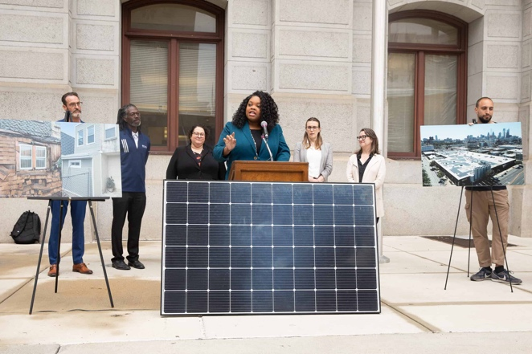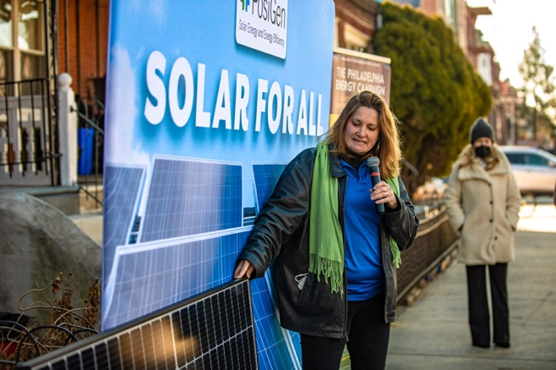

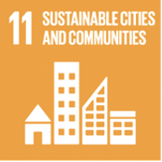

**Success Measurement:**

* **Investment:** The campaign aims for $1 billion by 2026, with over $380 million deployed as of 2022
* **Job Creation:** The goal is 10,000 jobs, with 3,275 created by the end of 2022, including 771 in 2022 alone.
* **A map of a city with many points of location

  Description automatically generatedProject Deployment:** Metrics include the number of homes with solar installations, energy efficiency upgrades, and other green initiatives. For example, the Philly Streetlight Improvement Project is projected to municipal carbon emissions by at least 9%.

**Federal Funding Boost Energy Efficiency at Philly Schools**

# SEPTA’s Sustainability Program

SEPTA’s Sustainability Program was initiated to enhance the environmental performance of Philadelphia’s public transportation system. As one of the largest transit agencies in the U.S., SEPTA recognized the need to reduce its environmental impact while improving operational efficiency and service quality. The program aims to address issues such as greenhouse gas emissions, energy consumption, and resource use.

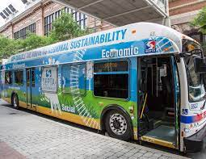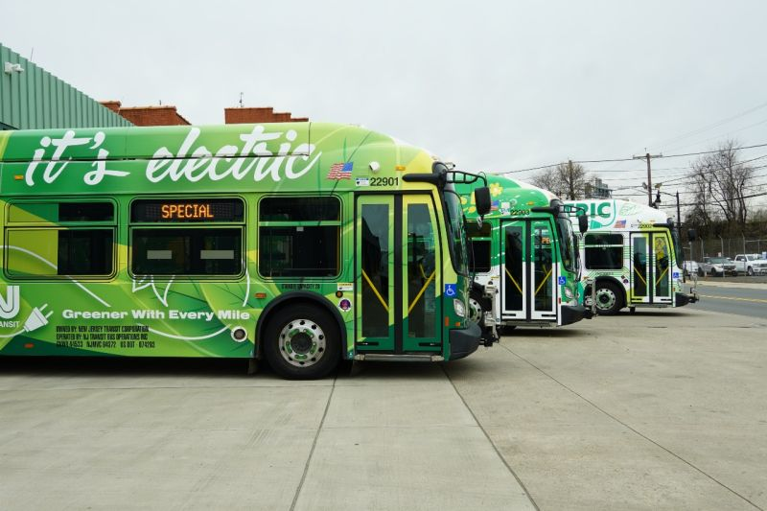

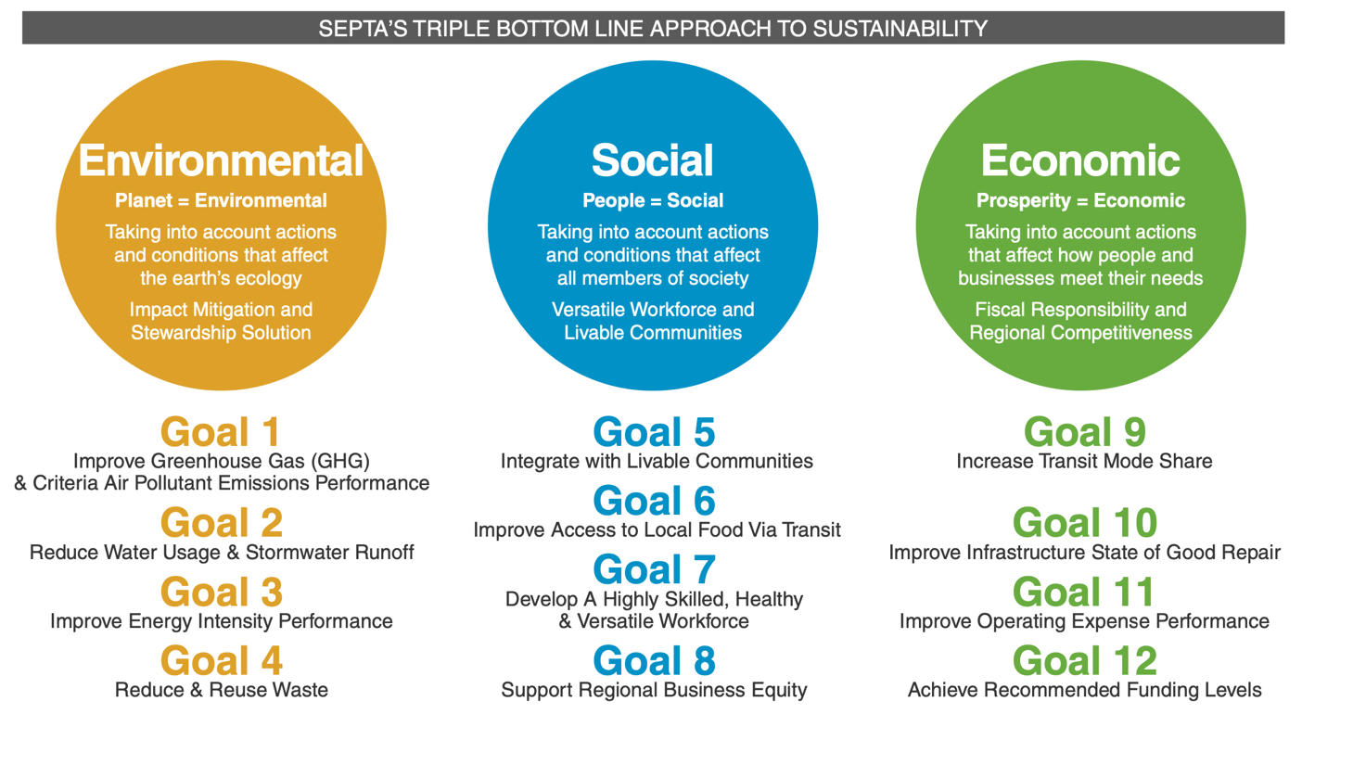

**Design and Development**

* **Hybrid and Electric Buses:** SEPTA has invested in a fleet of hybrid and electric buses to reduce emissions and improve fuel efficiency. By 2022, SEPTA had over 300 hybrid buses in operations
* **Energy Efficient Facilities:** Upgrades to facilities, including the installation of energy-efficient lighting, HVAC systems, and solar panels have been implemented to reduce energy use and operational costs
* **Recycling and Waste Reduction:** The program emphasizes waste management, including recycling initiatives and efforts to reduce waste generated by operations and maintenance activities
* **Green Infrastructure:** The program includes tree planting and stormwater management projects at various stations to reduce runoff and improve the environment. For example, 70 trees were planted at five project sites in 2014.

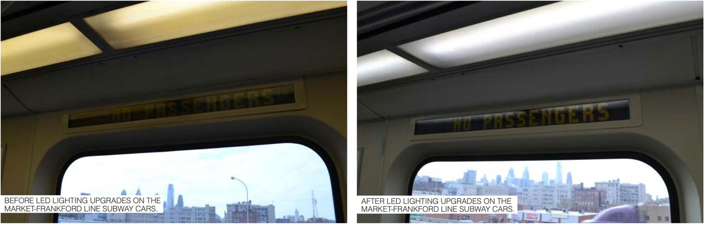

SEPTA began replacing incandescent lights with LED lights. Once the entire fleet is retrofitted with LEDs, SEPTA will save over $42,000 a year

# Philadelphia Urban Agriculture Initiative

The Philadelphia Urban Agriculture Initiative was established to address food insecurity, promote local food production, and revitalize urban spaces. The initiative was driven by the need to provide fresh, affordable produce to residents, particularly in low-income neighborhoods. Over the years, Philadelphia has faced significant challenges related to food deserts and limited access to healthy foods, prompting the city to focus on urban agriculture as a viable solution.

**COMMUNITY ENGAGEMENT**

**EDUCATION AND TRAINING**

**ACCESS TO RESOURCES**

**POLICY SUPPORT**

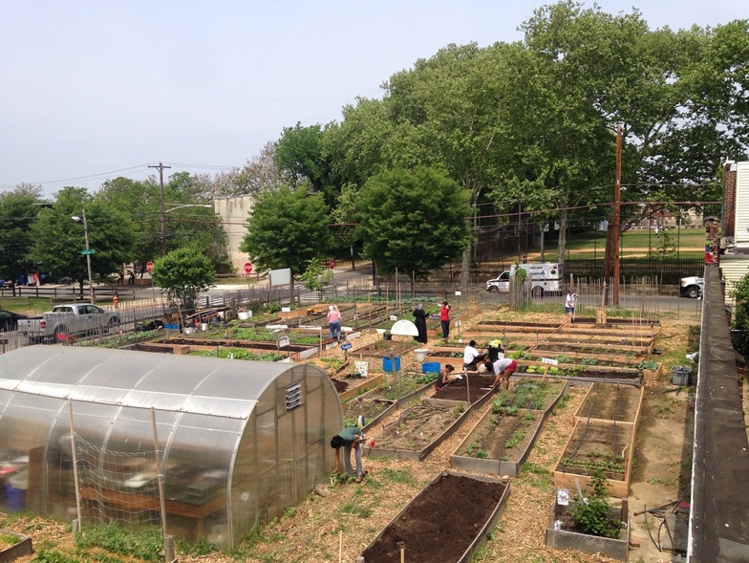The success of the Philadelphia Urban Agriculture Initiative is driven by active community engagement, empowering residents through education and training in sustainable farming practices, securing necessary resources through partnerships and receiving policy support from city government. These factors ensure the sustainability and growth of urban agriculture projects across the city.

***Commit to collaborative food policy development that elevates urban agriculture as a permanent, viable, productive land use in the City***

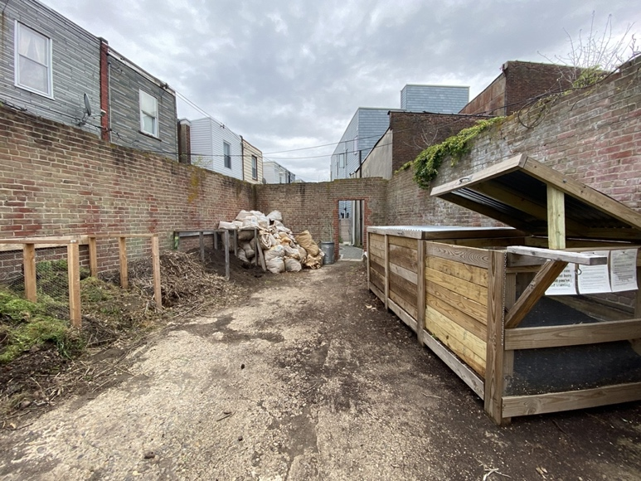

***Redistribute resources to communities impacted by historical and ongoing disinvestment, food apartheid, and displacement***

***Ensure equitable distribution of food produce on all public land***

***Support residents and communities to design and lead their own agriculture projects***

# Conclusion:

Philadelphia’s commitment to sustainability is clearly demonstrated through the diverse and impactful projects detailed in this portfolio. The Green City Clean Waters Program, Philadelphia Energy Campaign, SEPTA’s Sustainability Program, and the Philadelphia Urban Agriculture Initiative each address critical aspects of urban sustainability ranging from stormwater management and energy efficiency to sustainable transportation and local food production. These initiatives not only align with several UN Sustainable Development Goals, but significantly enhance the quality of life for Philadelphia residents.

By focusing on comprehensive planning, community engagement, and innovative technologies, Philadelphia is making steady progress toward creating a more sustainable and resilient city. The success of these programs are measured through various metrics such as reduced greenhouse gas emissions, increased energy savings, improved air and water quality, enhanced food security, and greater community involvement. More importantly, continuous improvement is essential. Expanding outreach efforts, securing additional funding, and integrating sustainability into more aspects of urban planning and development will further strengthen these initiatives.

# References

Clarke, D., & Richardson, K. (2023). Philadelphia Energy Campaign [Online Magazine ]. In *phlcouncil.com*.

*Green City Clean Waters*. (n.d.). Water.phila.gov; Philadelphia Water Department.

Herndon, L. (2014, March 28). *Financing Urban Agriculture: A Growing Field of Possibilities*. Etc.web.unc.edu; UNC School of Government, Enviromental Finance Center.

Mayor Kenney, J. (n.d.). *GREENWORKS: A Vision for a Sustainable Philadelphia*. Phila.gov; City of Philadelphia Office of Sustainability.

*Mission & Values*. (n.d.). Farmphilly.org; Urban Agriculture Program of Philadelphia Parks & Recreation.

*Philadelphia’s Urban Agriculture Plan: Growing from the Root*. (2023). Phila.gov; Philadelphia Parks and Recreation: FarmPhilly.

Rehm, D. (2023). Heat Pumps, Electric Vehicles and the Push Toward Net-Zero Emissions [Online Image]. In *wamu.org*.

Sandiford, D. (n.d.). “It’s Electric” Picture of City Bus [Online Image]. In *Linkedin*.

*SEP-TAINABLE Annual Report*. (2015, April). Planning.septa.org; SEPTA Sustainability.

*SEPTA Sustainability Playbook*. (2024). Septa.org/Sustain; SEPTA Sustainability.

*The Philadelphia Energy Campaign Annual Report 2022*. (n.d.). Philaenergy.org; Philadelphia Energy Authority.

*Transforming Our World: The 2030 Agenda for Sustainable Development*. (n.d.). UNITED NATIONS.